MGMS – Apply to proposal

Detailed Design Document

Ver. 1.4

Version History
Date | Description
20-Nov-2010 | First draft

Table of Contents

Version History 2
1 Introduction 4
2 Apply to proposal 4
3 Associated tables 4
4 Data Dictionary 5

Introduction

This document provides the detailed design specifications for the Multisite Grant Management System project.

This is not a project plan nor does it detail the source code. It is a guide for system architecture and development, not for phasing, timelines or deliverables.

Finally, this is a ‘living document’ and the specification will change, continuously, as the project proceeds. More details will be added and the existing information edited as the requirements, architecture and design evolve in the course of the project.

Apply to proposal

Screen & Control Description

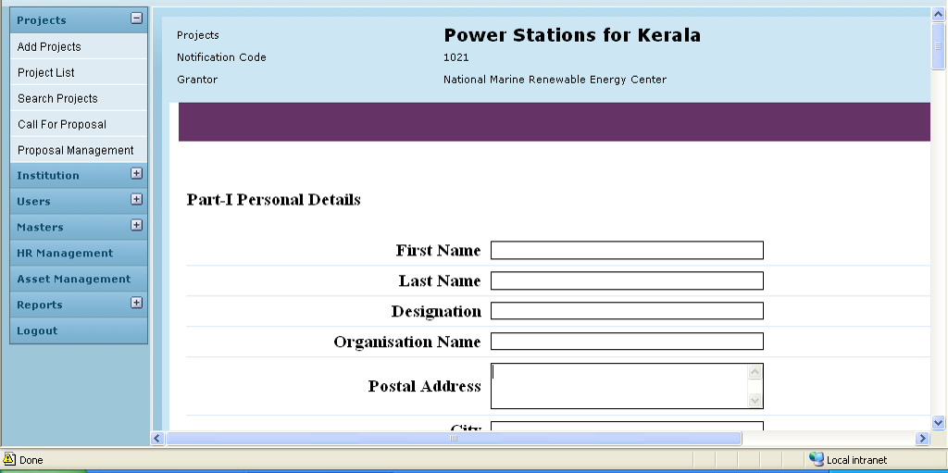

Field /Label | Input-Control | Data Type
Projects | Auto populated | projects>name
Notification Code | Auto populated | notification>notification_code
Grantor | Auto populated | party>name_of_the_institution
The relevant application form is expanded in editable format.
Save | Button

Associated tables

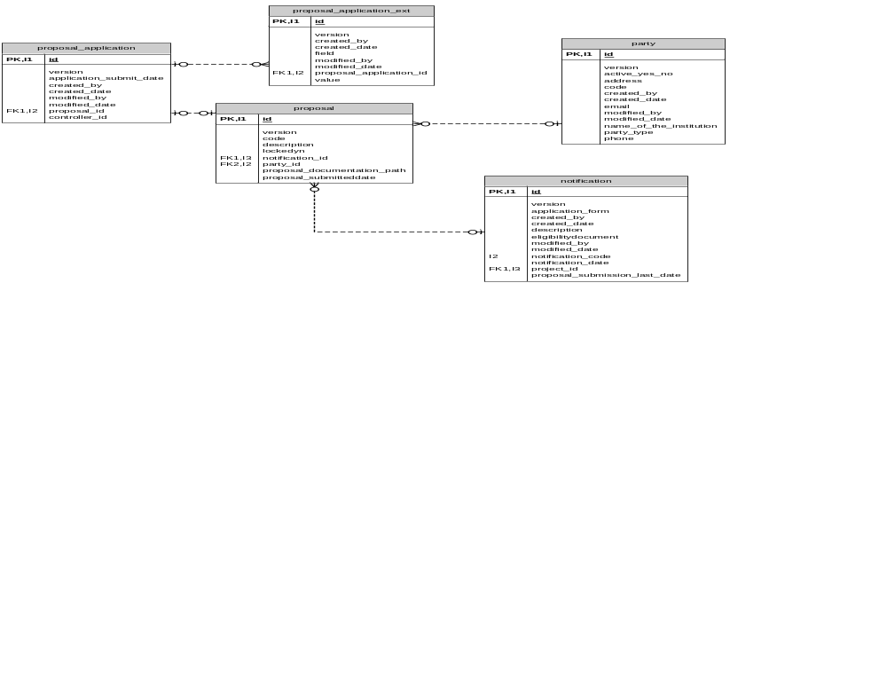

Data Dictionary

